Press Release

Your point of contact
Simone Pickhardt

Tel. +49 176 108 59 361
pickhardt@abicor-group.com
www.abicor-group.com

ABICOR GROUP
Management GmbH
Kiesacker
35418 Buseck / Deutschland

February 1st, 2024

Under one roof and management – ABICOR BINZEL and Thermacut become part of the new ABICOR GROUP

IBG Industrie-Beteiligungs-Gesellschaft mbH & Co KG today presented a significant milestone in its corporate history. As of February 2024, the Cologne-based company will unite their cutting and welding companies in one joint group.

The newly founded group will carry the name ABICOR GROUP and will consist of the IBG companies ABICOR BINZEL, Thermacut as well as HERR Industry System, PT Photonic Tools, Astaras, Cantesco and Weldstone.

Leadership of the group is an experienced management team headed by the new CEO, Prof. Dr. Emil Schubert which is responsible for over 2,200 employees around the globe.

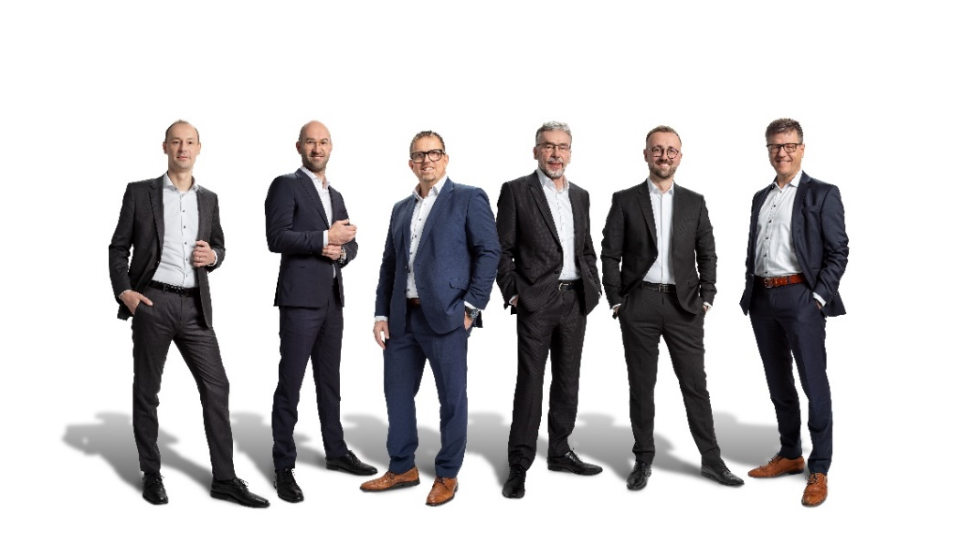
The Management Board of ABICOR GROUP l.t.r.: Dr. Sascha Rose (CTO), Philip Röhrig (COO), Frank Müller (CMO), Prof. Dr. Emil Schubert (CEO), Danny Maxeiner (CFO), Andreas Böckling (CSO)
(Picture: ABICOR GROUP)

"The unification of our brands under one roof and management is a fantastic milestone that enables us to bundle expertise and resources for the development of innovative solutions for our customers as well as benefit from synergy effects. At the same time, we can strengthen our presence in the market. However, it is particularly important to us that our strong and established product brands retain their unique identity," explains Schubert.

Andreas Boeckling, CSO of the new ABICOR GROUP, adds: "In future, we will be able to offer our customers an expanded product and service portfolio. It is especially important to us, to meet the increasing requirements in the field of automation and system solutions and by doing so, continue to focus on the customer benefit of our products as well as the safety and health of the welders."

The ABICOR GROUP companies are represented at 12 production sites and in more than 50 countries worldwide. The company's headquarters is in Buseck near Giessen.

You can also find further information at www.abicor-group.com

About IBG Industrie-Beteiligungs-Gesellschaft mbH & Co. KG

The IBG group consists of more than 2,500 employees in 75 subsidiaries spread across 50 countries worldwide and can now look back on a hundred years of company history.

In addition to IBG Industrie-Beteiligungs-Gesellschaft mbH & Co. KG as the parent company, the Cologne-based holding company comprises a large number of affiliated companies that represent the globally oriented operating activities. In the field of cutting and welding technology, these are leading companies such as the ABICOR BINZEL group and the Thermacut group, which offer a broad and innovative product range for all welding and cutting production processes, both for manual and automated welding and cutting.

About the ABICOR BINZEL group

Alexander Binzel Schweisstechnik GmbH & Co KG was founded in 1945 and is the international world market leader for gas-shielded welding and cutting torches under the ABICOR BINZEL umbrella brand. The company has its headquarters in Buseck, near Giessen, and develops and manufactures its products in Germany, India, China, Brazil and the USA. Today, more than 1,200 employees in 50 countries worldwide work for the company, which now also sets international standards for system solutions in automated welding, robot and laser technology as well as fume extraction technology.

You can also find further information at www.binzel-abicor.com

About Thermacut Group.

Thermacut "The Cutting Company" was founded in 1990 and has since developed into a renowned supplier of cutting technology. The company offers top-quality plasma, oxyfuel and laser cutting solutions. The extensive range of spare and wear parts for all common OEMs completes the product range. The high quality and reliability of Thermacut product solutions are appreciated all over the world.

You can also find further information at www.thermacut.com

